

FLY AWAY PLUS

Screen design

Hanoi, Jun/13/2015

Project Code: FAP

Document Code: FAP_ Screen Design_v1.0_EN

**SIGNATURE PAGE**

AUTHOR: Dương Thanh Hải 13/06/2015

Team member

REVIEWERS: Hoàng Nghĩa Đức 13/06/2015

Project Manager

APPROVAL: Nguyễn Văn Sang --/--/2015

Supervisor

**RECORD OF CHANGE**

*A - Added M - Modified D – Deleted

|  |  |  |  |  |  |
| --- | --- | --- | --- | --- | --- |
| Effective Date | Changed Item | A,M,D | Change Description | Reason for Change | Rev. Number |
| 13/Jun/2015 | Create Screen Design | A |  |  | 1.0 |
| 14/Jun/2015 | Update Screen Design | M |  |  | 1.1 |
|  |  |  |  |  |  |
|  |  |  |  |  |  |
|  |  |  |  |  |  |
|  |  |  |  |  |  |
|  |  |  |  |  |  |
|  |  |  |  |  |  |
|  |  |  |  |  |  |
|  |  |  |  |  |  |
|  |  |  |  |  |  |
|  |  |  |  |  |  |
|  |  |  |  |  |  |
|  |  |  |  |  |  |
|  |  |  |  |  |  |
|  |  |  |  |  |  |
|  |  |  |  |  |  |
|  |  |  |  |  |  |
|  |  |  |  |  |  |
|  |  |  |  |  |  |
|  |  |  |  |  |  |
|  |  |  |  |  |  |
|  |  |  |  |  |  |
|  |  |  |  |  |  |
|  |  |  |  |  |  |
|  |  |  |  |  |  |

# **INTRODUCTION**

## Purpose

To ensure consistency and simplicity in detailed design across all displays within a product interface, as well as across other products used by the same users. Definitions, acronyms, abbreviations, references and overview of FAP website.

## Definitions, Acronyms and Abbreviations

|  |  |  |
| --- | --- | --- |
| Abbreviations | Description | Comment |
| FAP | Fly Away Plus | Social network of travelling |
| Q&A | Question and answer |  |

## Overview

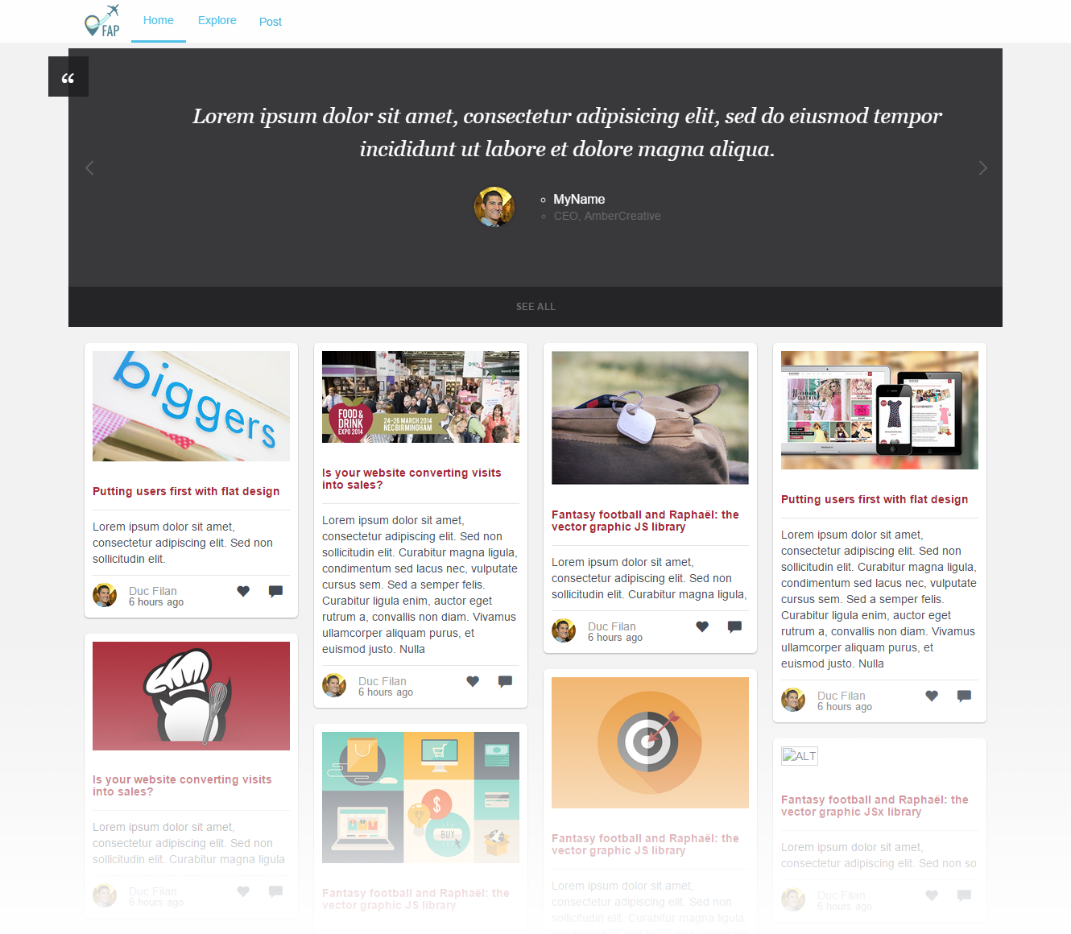

# **SCREEN FLOW**

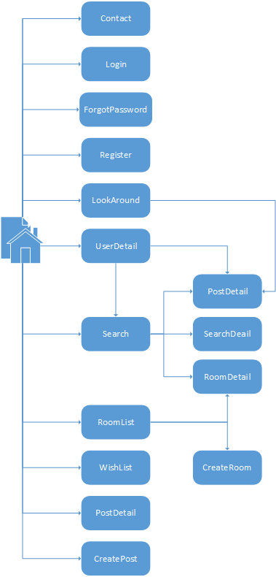

|  |  |  |
| --- | --- | --- |
| No | Screen Name | Description |
| 1 | Homepage | Homepage |
| 2 | Contact | Contact admin |
| 3 | Login | Login as a member |
| 4 | Register | Create New Account |
| 5 | Forgot Password | Get a new password in case of forgetting password |
| 6 | Look Around | Look around current position to find travelling places |
| 7 | User Detail | Timeline and information of user |
| 8 | Search | Search result |
| 9 | Room List | List of rooms |
| 10 | Search Detail | Detail information of a place |
| 11 | Room Detail | Detail information of a room |
| 12 | Post Detail | Detail information of a post |
| 13 | Wish List | List of places to visit in the future |
| 14 | Create Post | Create a post for a place |
| 15 | Create Room | Create a new room |

## Home page



### Figure 1: Home page

|  |  |  |  |  |  |  |  |
| --- | --- | --- | --- | --- | --- | --- | --- |
| No | Field name | Field name in Vietnamese | Type | Require | Mand-atory | Max-Length | Description |
| 1 | Logo | Logo | Image | Image |  |  | Logo of FAP website |
| 2 | Home | Trang chủ | Button | Click | Y |  | Redirect to home page |
| 3 | Post | Đăng bài | Button | Click | Y |  | User want to post a new post |
| 4 | Top Posts | Bài đăng tiêu biểu | Slide |  |  |  | Slide of top posts |
| 5 | Post List | Danh sách bài đăng | List |  |  |  | Show list of post |

## Login

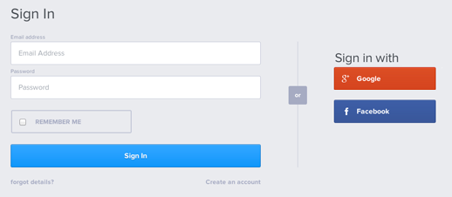

### Figure 2: Login

|  |  |  |  |  |  |  |  |
| --- | --- | --- | --- | --- | --- | --- | --- |
| No | Field name | Field name in Vietnamese | Type | Require | Mandatory | Max-Length | Description |
| 1 | Username | Tên đăng nhập | Text | Text | Y | 32 | User input username with length less than 32 character |
| 2 | Password | Mật khẩu | Password | Text | Y | 32 | User input their password with length less than 32 characters |
| 3 | Sign In | Đăng nhập | Button | Click | Y |  | User click on Sign In button |
| 4 | Sign in with Facebook | Đăng nhập bằng Facebook | Button | Click | Y |  | User click on Facebook button |
| 5 | Sign in with Google | Đăng nhập bằng Google | Button | Click | Y |  | User click on Google button |

## Register

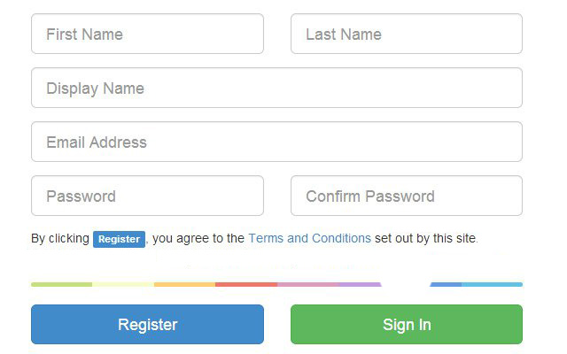

### Figure 3: Register

|  |  |  |  |  |  |  |  |
| --- | --- | --- | --- | --- | --- | --- | --- |
| No | Field name | Field name in Vietnamese | Type | Require | Mandatory | Max-Length | Description |
| 1 | Display Name | Tên đăng nhập | Text | Text | Y | 32 | User input username with length less than 32 characters |
| 2 | Password | Mật khẩu | Password | Text | Y | 32 | User input their password with length less than 32 characters |
| 3 | Confirm password | Nhập lại mật khẩu | Password | Text | Y | 32 | User re-input password with length less than 32 characters |
| 4 | First Name | Tên | Text | Text | Y | 34 | User input their first name with length less than 34 characters |
| 5 | Last Name | Họ | Text | Text | Y | 17 | User input their last name with length less than 17 characters |
| 6 | Email | Email | Text | Text | Y | 100 | User input email with length less than 100 characters |
| 7 | Register | Đăng ký | Button | Click | Y |  | User click Register button |

## Forgot password

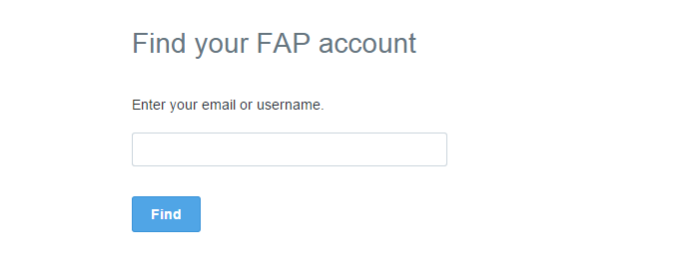

### Figure 4: Forgot password

|  |  |  |  |  |  |  |  |
| --- | --- | --- | --- | --- | --- | --- | --- |
| No | Field name | Field name in Vietnamese | Type | Require | Mandatory | Max-Length | Description |
| 1 | Email | Email | Text | Text | Y | 100 | User input email with length less than 100 characters |
| 2 | Find | Tìm password | Button | Click | Y |  | Click to receive password via email |

## Room list

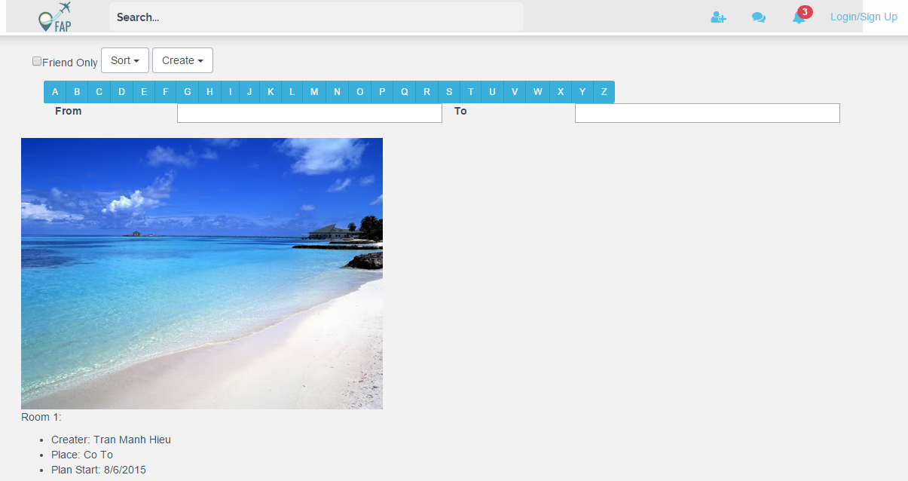

### Figure 5: Room list

|  |  |  |  |  |  |  |  |
| --- | --- | --- | --- | --- | --- | --- | --- |
| No | Field name | Field name in Vietnamese | Type | Require | Mandatory | Max-Length | Description |
| 1 | Button friend only | Chỉ cho phép bạn bè | Button | Click | Y |  | User click on button if he/she wants the room is avaiable for only friends |
| 2 | Button sort | Nút sắp xếp room | Button | Click | Y |  | Click to sort room list by name/date |
| 3 | Button create | Nút tạo room | Button | Click | Y |  | Click to create private or public room |
| 4 | Column character | Hàng chữ cái | String | Click | Y |  | Search room’s name by first character in room’s name |
| 5 | From/to textfield | Từ ngày đến ngày | String | Calendar | Y |  | Chose start & finsh day that user want |
| 6 | Room | Phòng | Room |  | Y |  | Display list room include: picture, creater’s name, place, day of start, member’s number, creater’s avatar, created time |

## Search detail

### Figure 6: Search detail

|  |  |  |  |  |  |  |  |
| --- | --- | --- | --- | --- | --- | --- | --- |
| No | Field name | Field name in Vietnamese | Type | Require | Mandatory | Max-Length | Description |
| 1 | Name of location | Tên địa điểm tìm kiếm | text |  | Y |  | Name of location that user search |
| 2 | Map | Bản đồ | Map |  | Y |  | Display location’s result in google map |
| 3 | Post tab | Kết quả tìm kiếm theo bài post | Tab | Click | Y |  | Display post related with search’s result |
| 4 | Rate tab | Kết quả tìm kiếm theo đánh giá | Tab | Click | Y |  | Display good and bad post about search’s result |
| 5 | Post | Các bài post được tìm kiếm | Post |  | Y |  | Display post which is search’s reuslt |

## Room detail

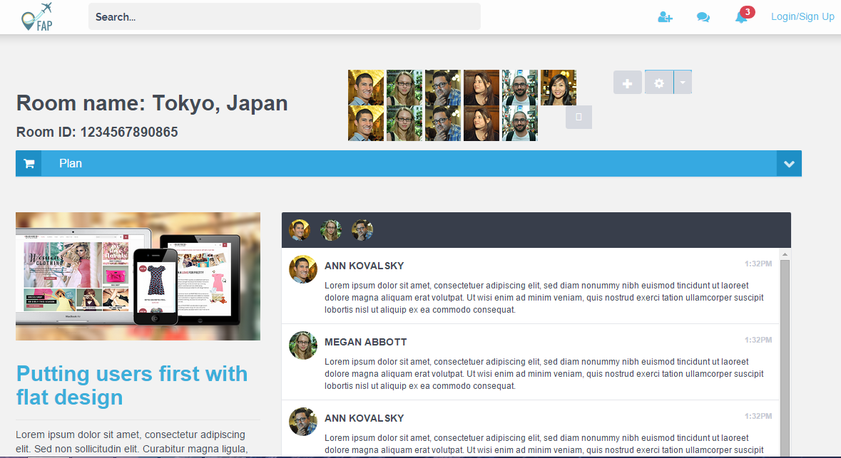

### Figure 7: Room detail

|  |  |  |  |  |  |  |  |
| --- | --- | --- | --- | --- | --- | --- | --- |
| No | Field name | Field name in Vietnamese | Type | Require | Mandatory | Max-Length | Description |
| 1 | Room name | Tên phòng | text |  | Y |  | Display room’s name |
| 2 | Room ID | ID của phòng | Text |  | Y |  | Display room’s ID |
| 3 | List member | Danh sách thành viên trong phòng | Image |  | Y |  | Display list of members in room |
| 4 | Invite button | Nút thêm thành viên, copy đường link room | Button | Click | Y |  | Click to add member to room or copy link and send to friends |
| 5 | Plan tab | Tab hiển thị kế hoạch chuyến đi | Tab | Click | Y |  | Display the journey’s plan include: over time, prepare, time line |
| 6 | Chat box | Khung chat | Chat box | Type | Y |  | Display conversation between members |

## Create room

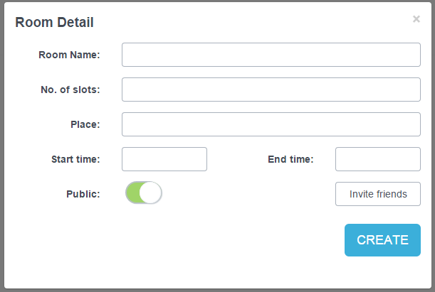

### Figure 8: Create room

|  |  |  |  |  |  |  |  |
| --- | --- | --- | --- | --- | --- | --- | --- |
| No | Field name | Field name in Vietnamese | Type | Require | Mandatory | Max-Length | Description |
| 1 | Room name | Tên phòng | text | Type | Y |  | User type room’s name |
| 2 | No. of slots | Số lượng thành viên | Number | Tyoe | Y |  | User type maxium number of members that can join room |
| 3 | Place | Địa điểm | Text | Type | Y |  | User chosse destination |
| 4 | Start time | Thời gian khởi hành | Text | Type | Y |  | User choose start time |
| 5 | End time | Thời gian kết thúc | Text | Type | Y |  | User choose end time |
| 6 | Public swithc | Chọn chế độ public/private room | Switch | Click | Y |  | User chosse public or private room |
| 7 | Invate friend | Mời bạn bè | Button | Click | Y |  | User chosse friend they want to join the room |
| 8 | Create | Tạo phòng | Button | Click | Y |  | User click to create room |

## Create post

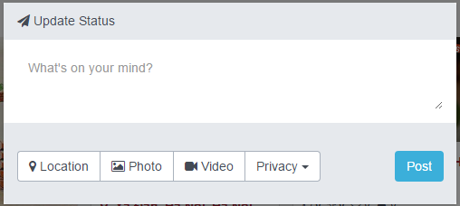

### Figure 9: Create post

|  |  |  |  |  |  |  |  |
| --- | --- | --- | --- | --- | --- | --- | --- |
| No | Field name | Field name in Vietnamese | Type | Require | Mandatory | Max-Length | Description |
| 1 | Post’s content | Nội dung bài post | Text area | Type | Y |  | User type post’s content |
| 2 | Locaition button | Nút chọn địa điểm | Button | Click | Y |  | User click to choose location in post |
| 3 | Photo button | Nút chọn ảnh | Button | Click | Y |  | User click to choose photo that want to add to post |
| 4 | Video button | Nút chọn video | Button | Click | Y |  | User click to choose video that want to add to post |
| 5 | Pivacy button | Nút chọn chế đồ post | Button | Click | Y |  | User click to choose public/private post |
| 6 | Post button | Nút đăng bài | Button | Click | Y |  | User click to finish the post |

## Wish list



### Figure 10: wish list

|  |  |  |  |  |  |  |  |
| --- | --- | --- | --- | --- | --- | --- | --- |
| No | Field name | Field name in Vietnamese | Type | Require | Mandatory | Max-Length | Description |
| 1 | Room name | Tên phòng | text | Type | Y |  | User type room’s name |
| 2 | No. of slots | Số lượng thành viên | Number | Tyoe | Y |  | User type maxium number of members that can join room |
| 3 | Place | Địa điểm | Text | Type | Y |  | User chosse destination |
| 4 | Start time | Thời gian khởi hành | Text | Type | Y |  | User choose start time |
| 5 | End time | Thời gian kết thúc | Text | Type | Y |  | User choose end time |
| 6 | Public swithc | Chọn chế độ public/private room | Switch | Click | Y |  | User chosse public or private room |
| 7 | Invate friend | Mời bạn bè | Button | Click | Y |  | User chosse friend they want to join the room |
| 8 | Create | Tạo phòng | Button | Click | Y |  | User click to create room |